**Experiment No. 9**

**Title :** Implement Java programs using pre-defined and user defined packages.

# Calculator Code:

package mypackage; public class Calculator

{

public int add(int a, int b)

{

return a + b;

}

public int multiply(int a, int b)

{

return a * b;

}

}

# User defined package Code:

import java.util.Scanner; import mypackage.Calculator;

public class User_Defined_Package

{

public static void main(String[] args)

{

Scanner sc = new Scanner(System.in); System.out.print("Enter first number: ");

int num1 = sc.nextInt();

System.out.print("Enter second number: ");

int num2 = sc.nextInt();

Calculator calc = new Calculator();

System.out.println("Addition: " + calc.add(num1, num2)); System.out.println("Multiplication: " + calc.multiply(num1, num2));

}

}

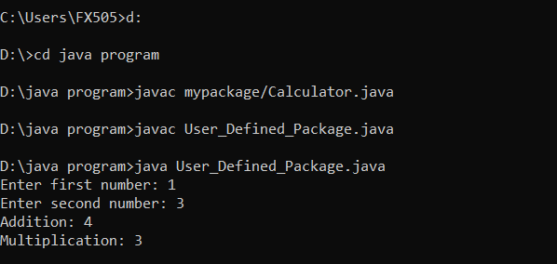**Output**